Chapter 10, Problem 58.

For the circuit depicted in Fig. 10.101, find the Thevenin equivalent circuit at terminals a-b.

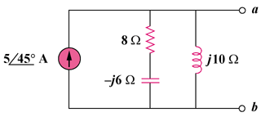

Figure 10.101
For Prob. 10.58.

